

Main insurer:
Generali Poisťovňa, a. s., odštepný závod Európska cestovná poisťovňa
Lamačská cesta 3/A, 841 04 Bratislava
IČO: 35 709 332, DIČ: 2021000487, IČ DPH: SK2021000487
Zapísaná v Obchodnom registri Okresného súdu Bratislava I, odd.: Sa, vložka č.: 1325/B. Spoločnosť patrí do skupiny Generali, ktorá je uvedená v talianskom zozname skupín poisťovní vedenom IVASS.

hereby confirms, that

Mr./Mrs. meno a priezvisko klienta (klientov), born: dátum narodenia

has concluded in our company travel insurance contract included in credit/debit card on the insurance protection in case of sudden disease or accident abroad.

Insurance contract is concluded between policyholder / card issuer: Fio banka, a. s., pobočka zahraničnej banky (company ID No. „IČO“ 36 869 376) and insurer: Generali Poisťovňa, a. s., odštepný závod Európska cestovná poisťovňa (company ID No. „IČO“ 35 709 332).

The insurer covers the following costs if they are required by the health condition of the insured:

- ambulant treatment and medicaments prescribed by the doctor
- hospitalization and medical treatment during hospitalization
- transport to the nearest health care establishment
- costs of repatriation of the insured in case that he will be unable to use the initially planned
means of transport for health reasons
- repatriation of the remains to the place of residence in case of the death of the insured
- provision of first aid

We cover the insurance event to € 80.000,- / 120.000,- / 160.000,-

Territorial validity: Whole world

Period of insurance from: …………….to: ………………….

The emergency hot-line of our company, which can be contacted in case of an insurance event abroad is the company Europe Assistance, tel.: +421-2-54417711.
You can verify the validity of this confirmation on telephone no. +421-2-54417704.

Wednesday, July 29, 2026

Generali Poisťovňa,a.s.,
odštepný závod Európska cestovná poisťovňa

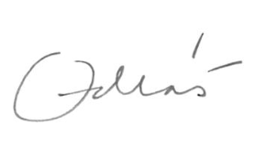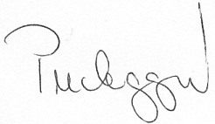
Ing.Milan Ondráš Anetta Pucheggerová
director head of management of insurance

